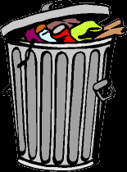

The average American throws away 3.5 pounds of trash
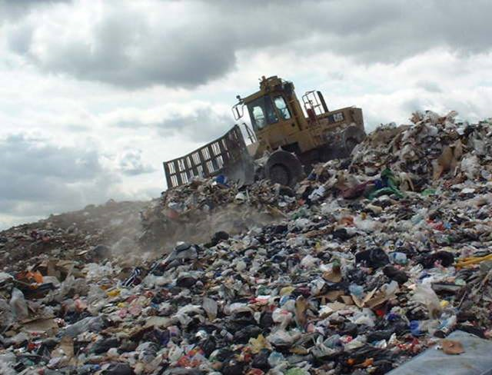
per day*

Recyclers wanted.

*Courtesy of MIT Working Recycling Group Ambassador Bryt Bradley


The average American uses 650 pounds of paper per year.*

Got conservation?

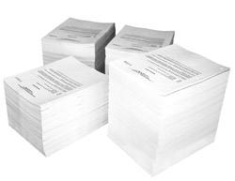

*Courtesy of MIT Working Recycling Group Ambassador Bryt Bradley

One ton of paper from recycled pulp saves:

- 17 trees
- 3 cubic yards of landfill space
- 7000 gallons of water
- 4200 kWh (enough to heat a home for half a year)
- 390 gallons of oil
- and prevents 60 pounds of air pollutants.*

Recycling: It does a planet good.

*Courtesy of MIT Working Recycling Group Ambassador Bryt Bradley



Look Ma, no trash!

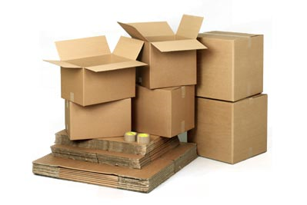
Recycling one ton of cardboard saves over nine cubic yards of landfill space.*

*Courtesy of MIT Working Recycling Group Ambassador Bryt Bradley

Recycling a soda can saves 96 percent of the energy used to make a can from ore and produces 95 percent less air pollution and 97 percent less water pollution.*
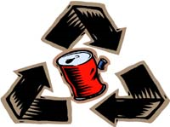
Friends Don't Let Friends Throw Away Recyclables
*Courtesy of MIT Working Recycling Group Ambassador Bryt Bradley


Every ton of newspaper recycled saves 4100 kWh or enough energy to power a TV for 31 hours.*



A planet is a terrible thing to waste.

*Courtesy of MIT Working Recycling Group Ambassador Bryt Bradley
Recycling one ton of newspaper saves 17 trees*
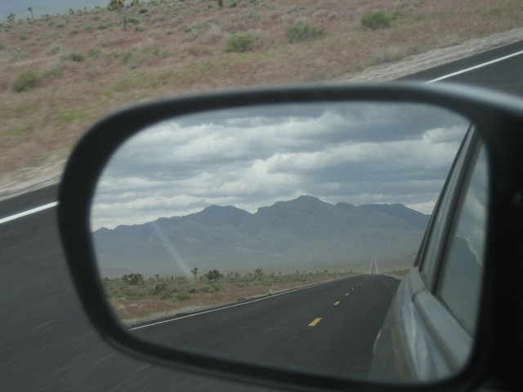

Objects in [recycling] bin are mightier than they appear

*Courtesy of MIT Working Recycling Group Ambassador Bryt Bradley

